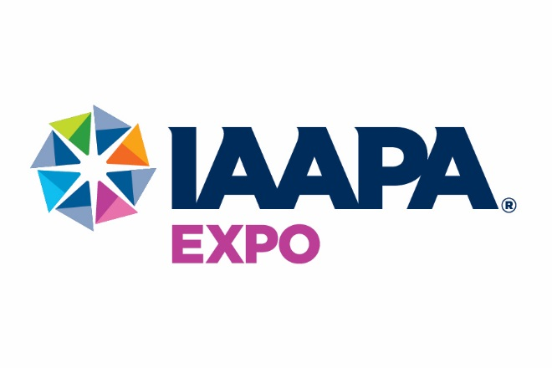

HOTEL ROUTES BOARDING LOCATIONS HOTEL ROUTES BOARDING LOCATIONS

**RED ROUTE ONE YELLOW ROUTE FOUR**

Homewood Suites At Fountain by Residence Inn Crowne Plaza Universal Curbside on Universal Blvd.

Hampton Inn At Fountain by Residence Inn Wyndham Orlando Resort Convention Entrance

**BLUE ROUTE TWO** **ORANGE ROUTE FIVE**

Embassy I-Drive 360 Curbside on Jamaican CourtVista Cay Resort Curbside on Cayview Ave.

Embassy Suites I-Drive I-Ride Trolley Stop #17

Rosen Plaza I-Ride Trolley Stop #20

**GREEN ROUTE THREE WALKING HOTELS (Service only for IAAPA Celebrates)**

Hilton Garden Inn SeaWorld Curbside on Westwood Blvd. Hilton Orlando Group Arrival Bus Zone

Doubletree Orlando SeaWorld Lobby Bus Lane Hyatt Regency Orlando Convention Entrance Rosen Centre Signature Entrance

**\*\*FACE MASKS ARE REQUIRED AT ALL TIMES ON SHUTTLE BUSES\*\***

HOURS OF SERVICE

**Sunday, November 14 7:00am – 10:30am Every 30 minutes**

**4:00pm – 7:00pm* Every 30 minutes**

**Monday, November 15 7:00am – 10:30am Every 15-20 minutes**

**3:00pm – 6:30pm* Every 15-20 minutes**

**Tuesday, November 16 7:00am – 10:30am Every 10-15 minutes**

**4:00pm – 8:30pm* Every 10-15 minutes**

**Wednesday, November 17 7:00am – 10:30am Every 10-15 minutes**

**4:00pm – 8:30pm* Every 10-15 minutes**

**Thursday, November 18 7:00am – 10:30am Every 10-15 minutes**

**4:00pm – 6:45pm* Every 10-15 minutes**

**Friday, November 19 8:00am – 10:30am Every 15-20 minutes**

**2:30pm – 5:00pm* Every 15-20 minutes**

PLEASE NOTE: Buses will drop off and pickup on the North Side of the

Convention Center first then proceed to the South Side.

**\*Last bus departs from the hotels to the Convention Center one hour prior to the end of service**

“IAAPA CELEBRATES:

AT DISNEY’S HOLLYWOOD STUDIS”

**Thursday, November 18**

8:45pm – 9:15pm

One-way transfer from Shuttle Routes and Walking Hotels to IAAPA Celebrates at Disney’s Hollywood Studios. Buses depart at 8:45pm from the first hotel on the route, continuing down the route to the last hotel at 9:15pm.

11:30pm – 12:30am

Shuttle service from IAAPA Celebrates at Disney’s Hollywood Studios to Shuttle Routes and Walking Hotels.

Every 20-30 minutes

**\*Attendees may drive themselves and will be responsible for parking charges.**

**C:\Program Files (x86)\Microsoft Office\MEDIA\CAGCAT10\j0293238.wmf**

Transportation Managed by: The Convention Store, Inc.

FOR SHUTTLE INFORMATION & SPECIAL ASSISTANCE

**443-618-2805**

If you need to arrange wheelchair-accessible transportation, please call at least 60 minutes prior to pick-up.